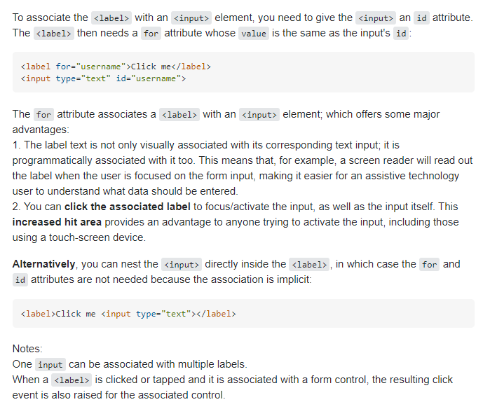

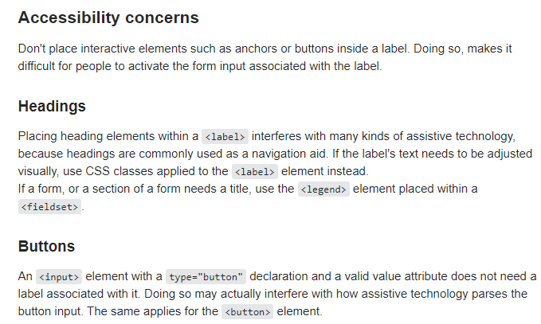

Ref: <https://developer.mozilla.org/en-US/docs/Web/HTML/Element/label>